**Help Manual of Job Portal**

**Requirements on Job Portal**

* Jobseeker Panel
* Employer panel
* Admin control Panel

**Job Seeker Section**

**Home Page - Site Map**

|  |
| --- |
| **HOME** |
| **Search Job** |
| **My Profile** |
| **Resume** |
| **Career Opportunity** |
| **About Us** |

**Home**

* + **Registration Steps** ( Basic Steps) (New User » Register)

»Personal Details

»Educational Details

»Professional Details

» Button Shows » Create My Profile

* + **Search job**

» Job Details

» Company Details

» Button Show » View Apply Jobs

(Candidate can apply the Jobs After login)

* + **My Profile**

» Contact Details

» Educational Details

» Professional Details

» Button Show » View profile

(Candidate can View their Profile in Grid view After login)

* + **Resume**

» Resume Update

» Attached Resume

» Resume Display

» Button Shows » Save Resume

(Candidate can View Or Update their Resume in Grid view After login)

**Job Seeker Section (After Login)**

1. **Search Jobs**

(Search the jobs in terms of Advance Search, Post, Area, Salary Range, Job Category, Location etc.)

1. Basic Search

Search Job vacancies in terms of Job Category

1. Advanced Search – in terms of different criteria and saved details
2. Attach CV

Attach New CV and Deleting Existing CV.Maximum 5 CV can Attached

1. Download CV

Candidate can download their CV from server

1. **My Profile**

» View /Edit Profile » Edit Personal Details

(Candidate can see the details of 3 different CV) complete status of CV individual

* + Contact Details
  + Educational Detail
  + Professional Details

1. **Resume Upload** (After Login)

a. CV

* Cv Code
* Cv Title
* View
* Preview CV - View Any format
* Edit – update Complete Details Related with CV

b. Search agent

* Search Agent Details (Candidate can save Search Result)
* Add More Search Agent

d. Apply History (Candidate Can view their Applied Jobs)

* Company Details
* Cv Status
* View

**Jobseeker’s Panel:**

1. View/Edit resume: Free Resume Posting and Premium Resume Posting
2. Restrictions of few fields for “Resume Posting”
3. Manage Search Criteria
4. New Applications
5. View Applications Status
6. Search Jobs
7. Candidate to Candidate referral system, where we can see, how many candidates have been referred by a candidate, present status of profile (completed/uncompleted), Plan status.
8. Candidate can put his referral person mail while making their profile.

**Jobseeker Section Screen shot**

Jobseeker’s Home page

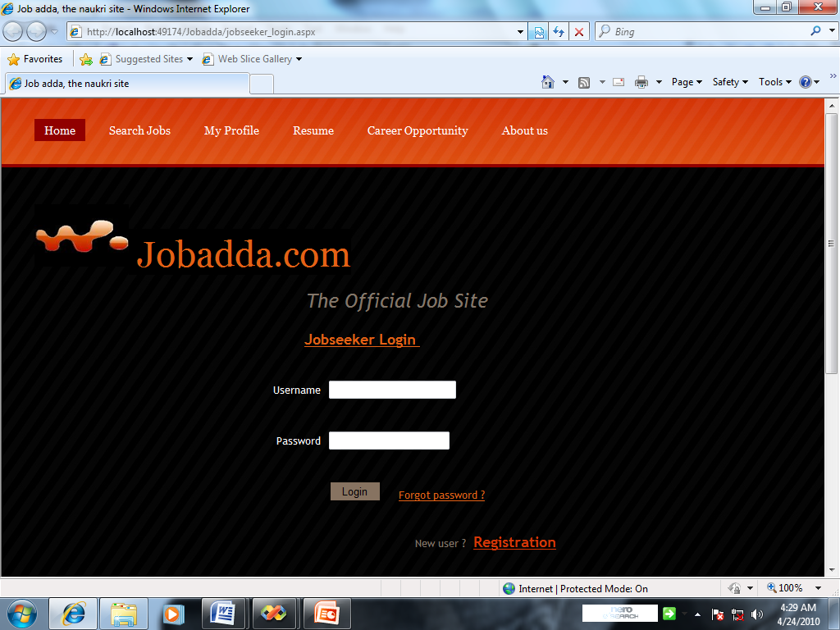

New Registration:

Personal Details

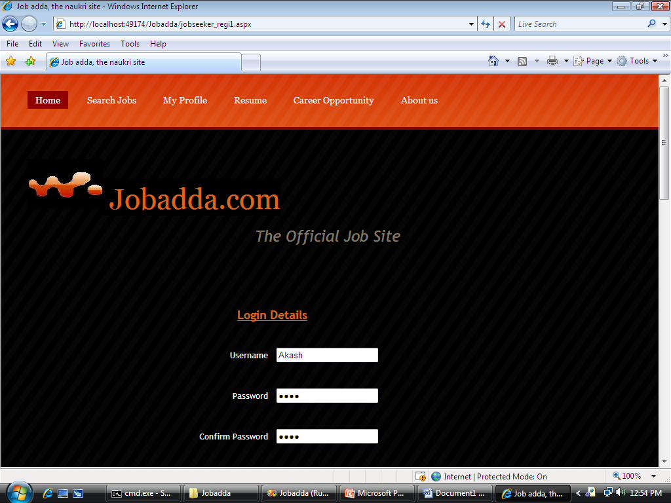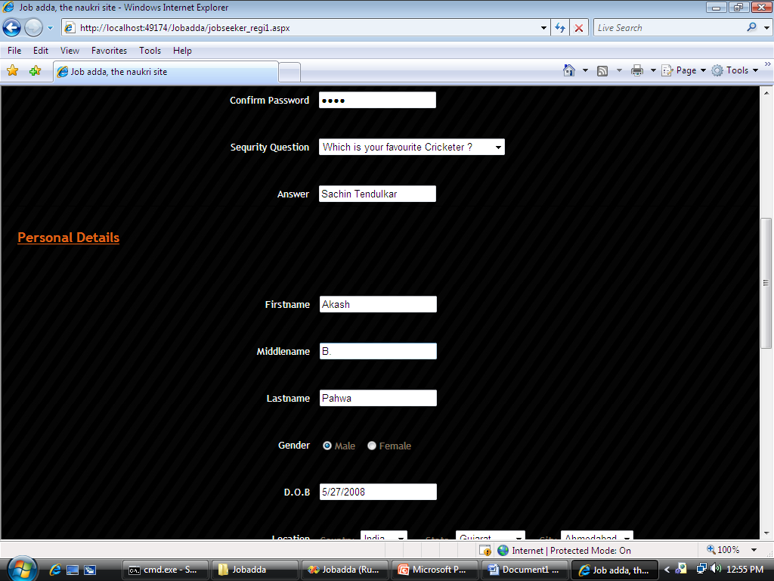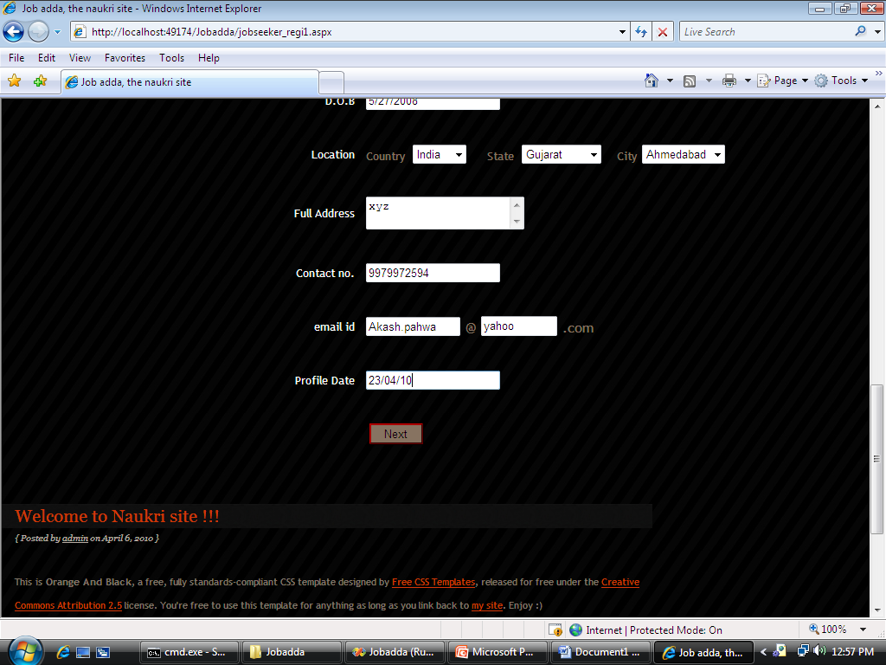

Education Details

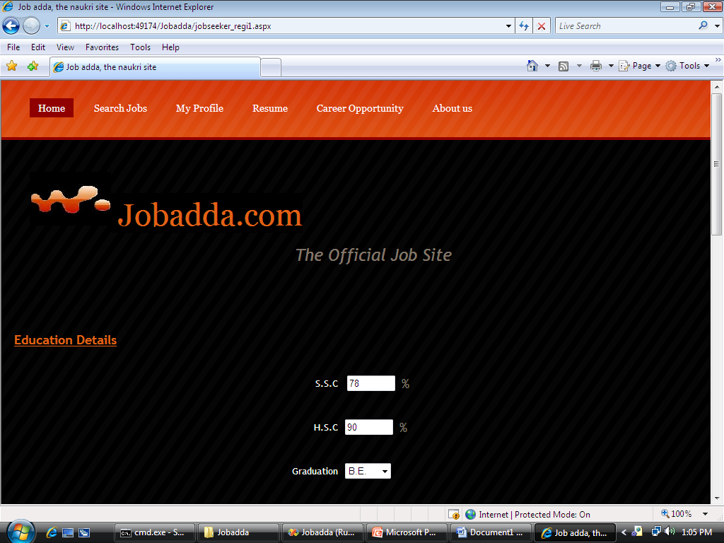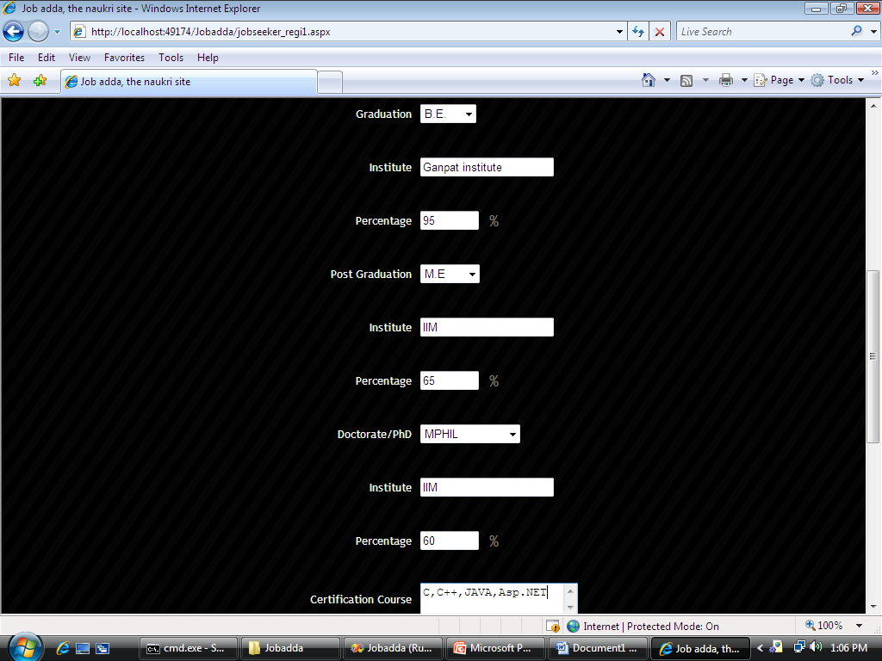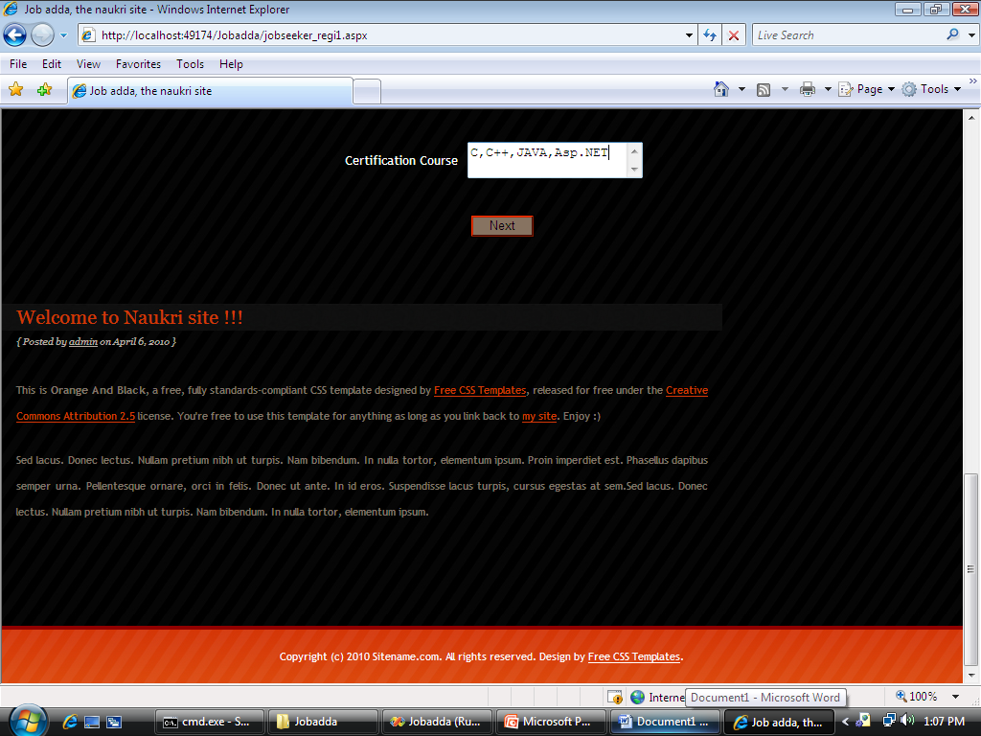

Professional Details

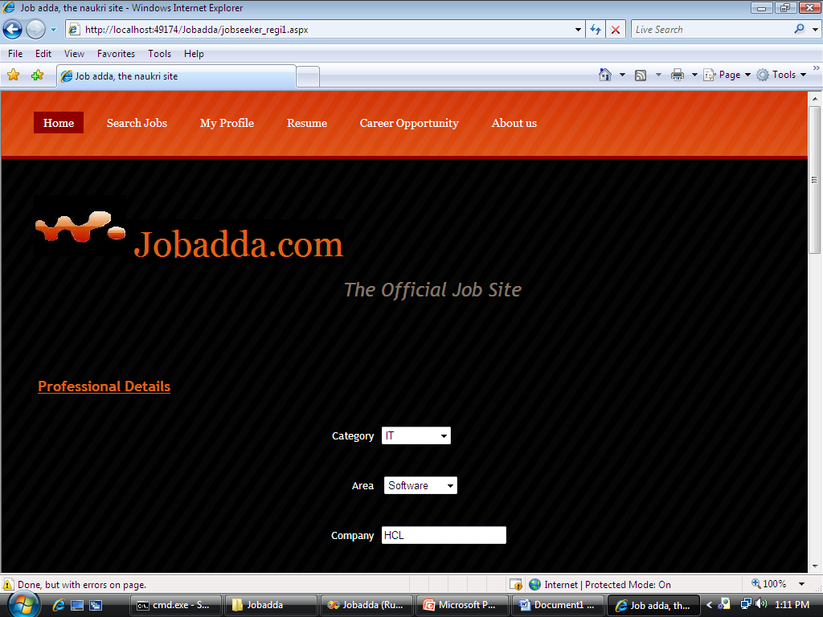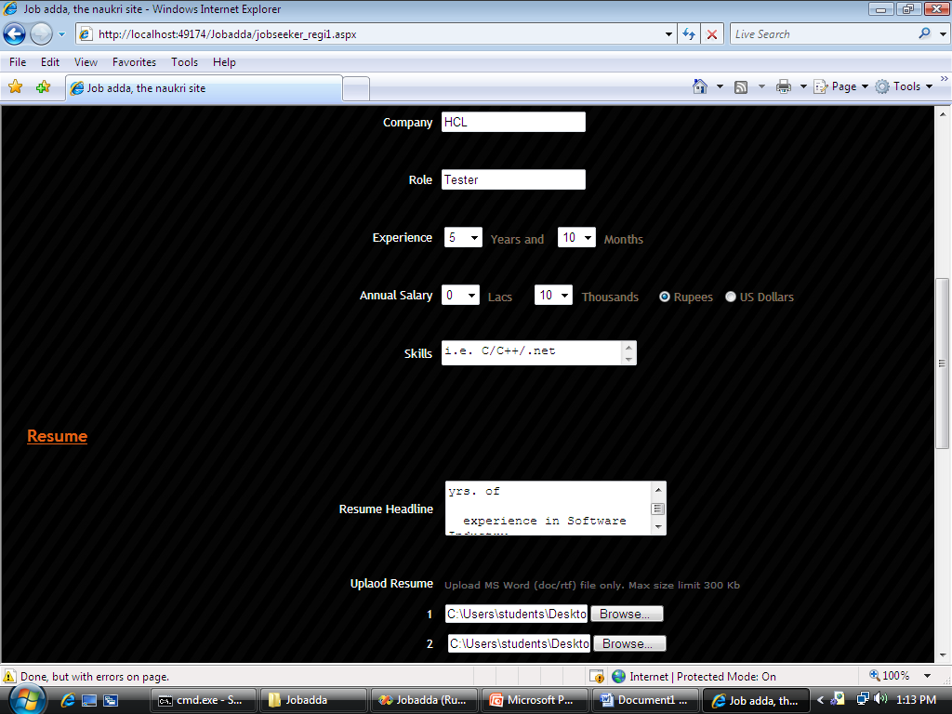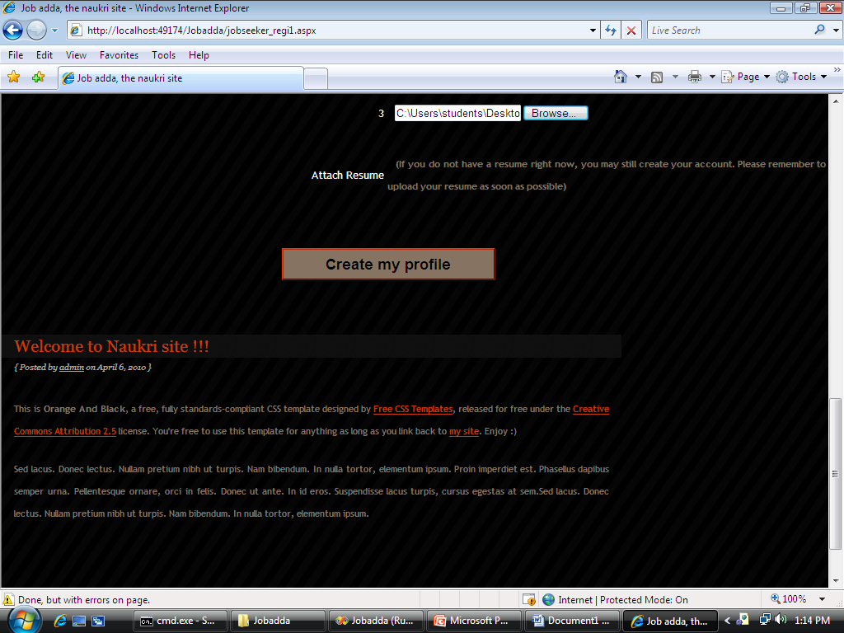

Jobseeker login

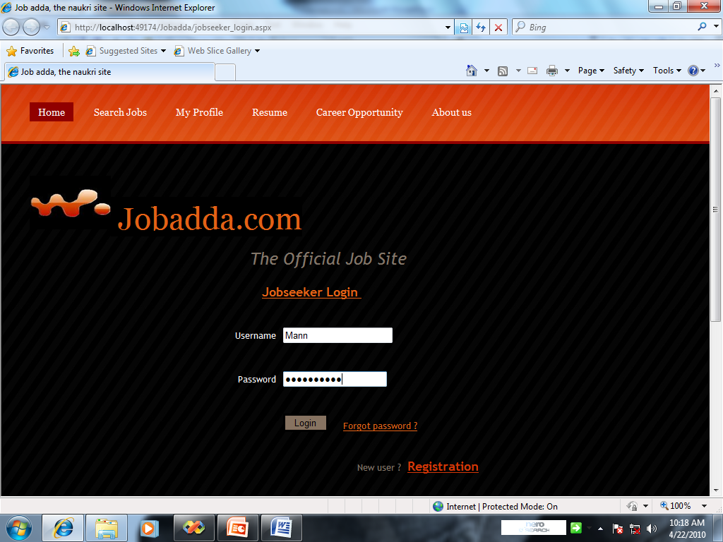

Your active profile

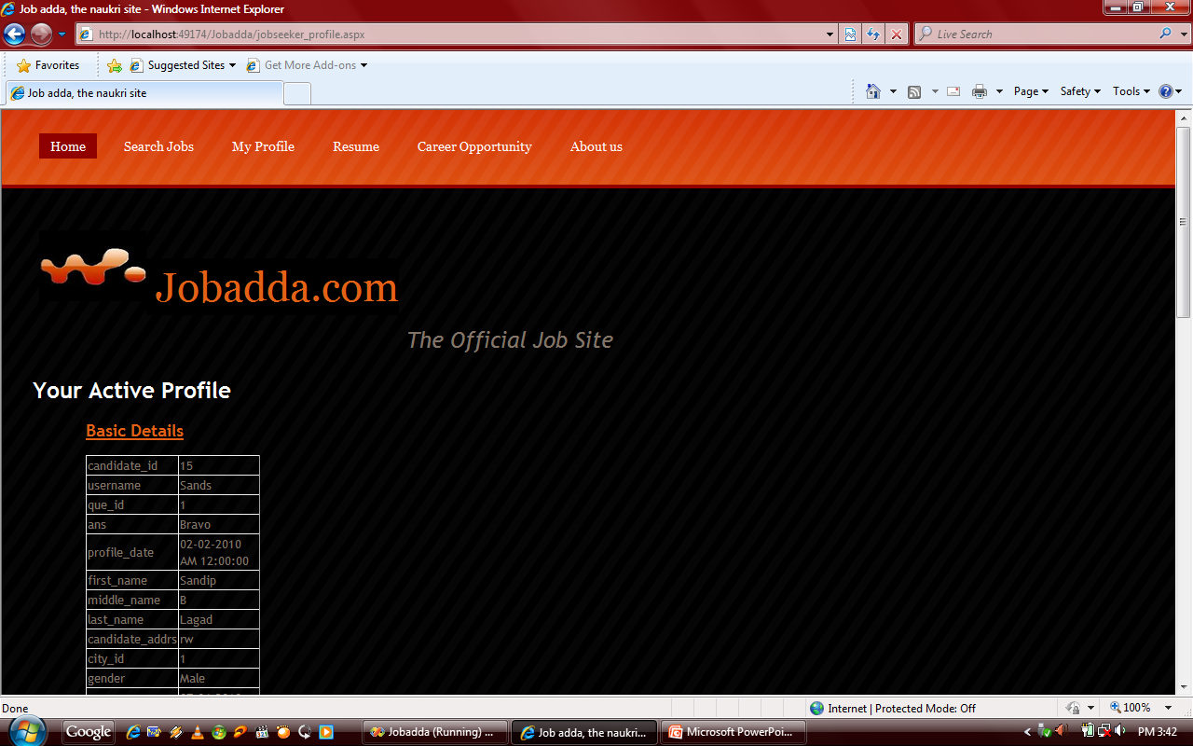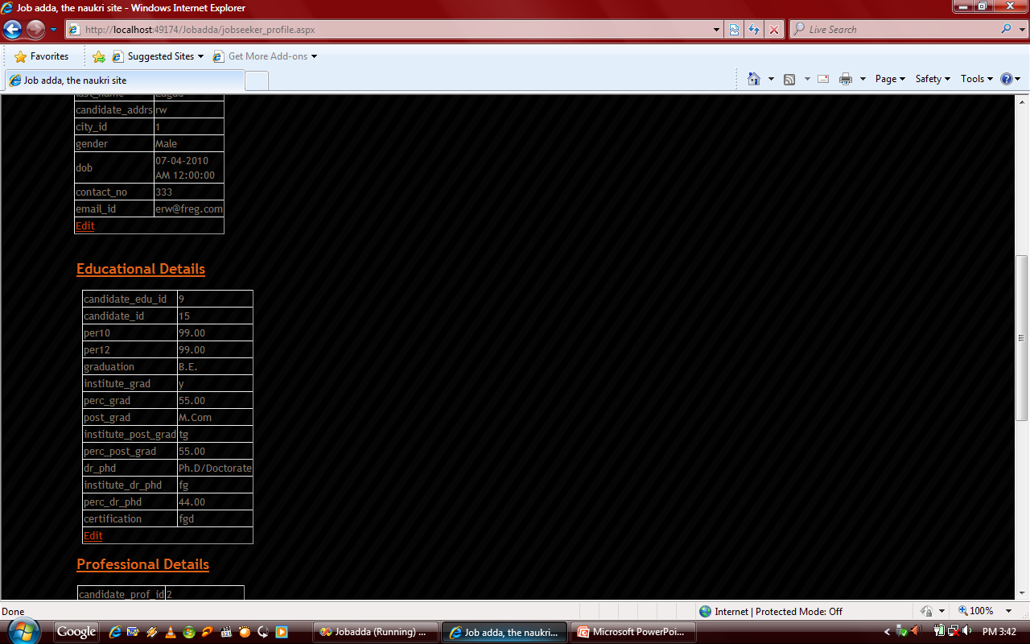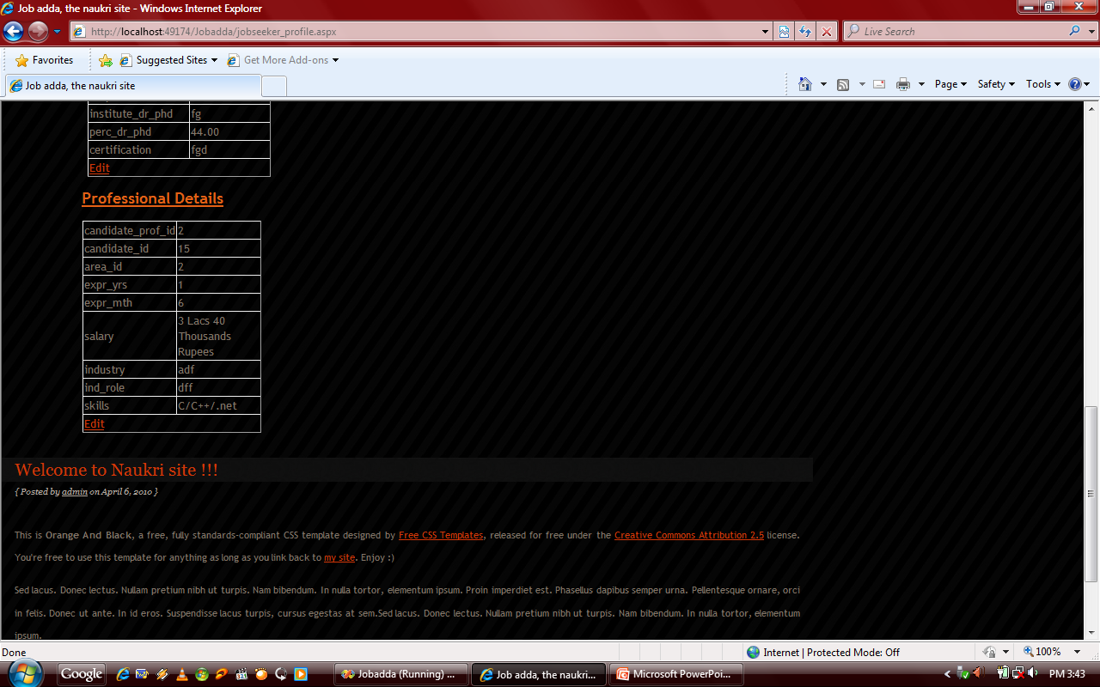

Forgot Password

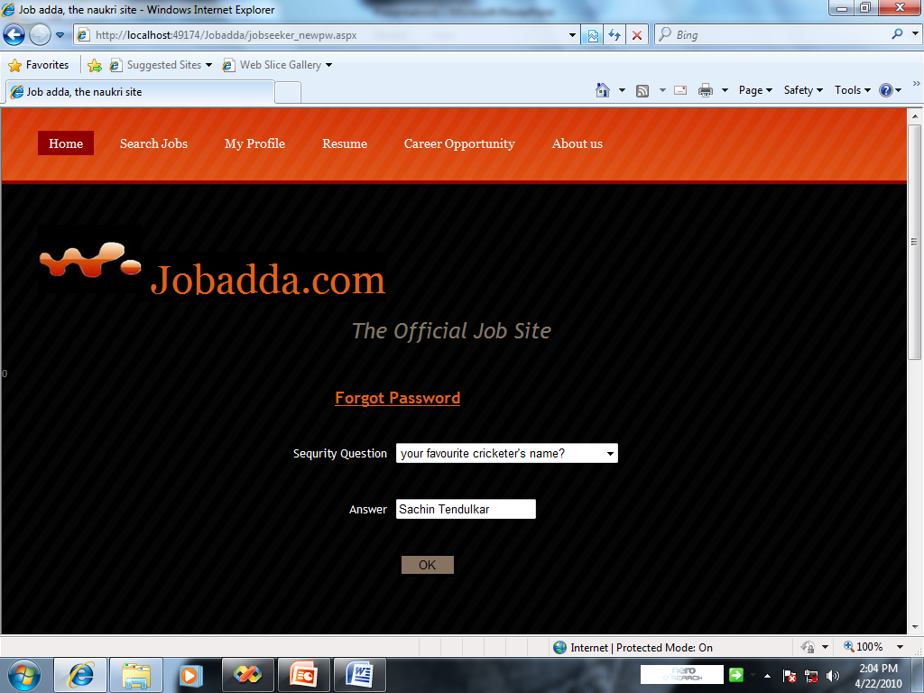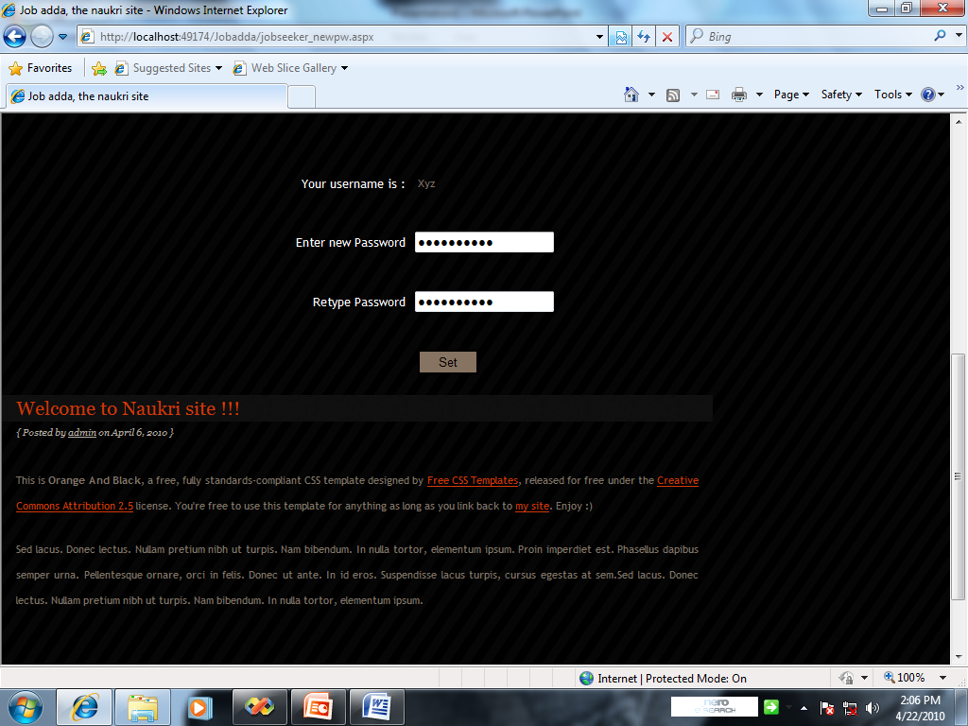

Search Jobs

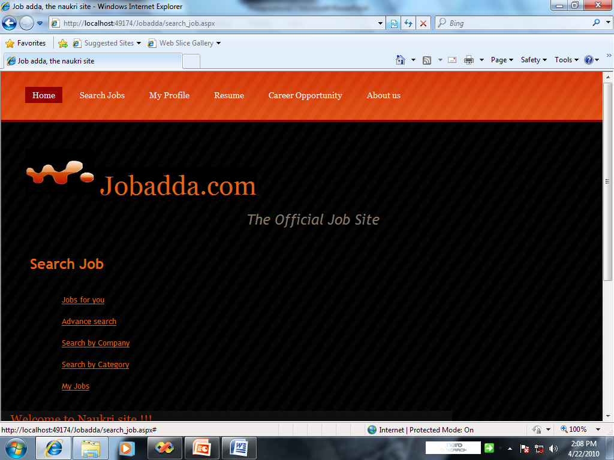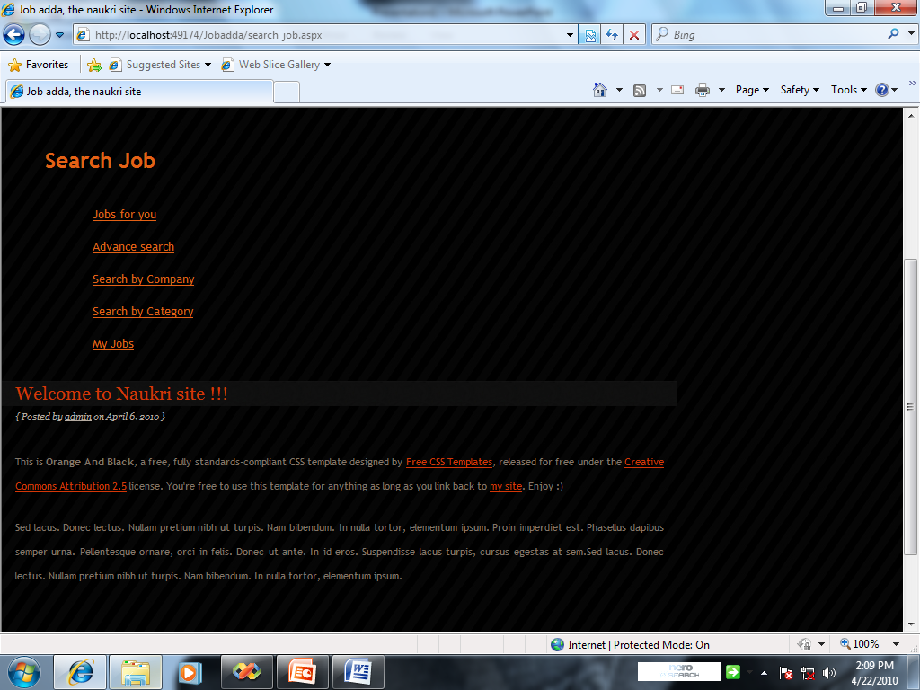

**Employer Section**

|  |
| --- |
| **Home** |
| **Your Profile** |
| **Search Candidates** |
| **Recruiter login** |
| **Job Posting** |
| **Post Job** |
| **Search by category** |
| **Search by company** |
| **Search Candidate** |
| **Select Package** |
| **Selected Candidate** |
| **Recruiter Profile** |
| **Recruiter registration** |

**2. Account**

* 1. Job Posts (Post Job / Buy Job Post)
  2. CV Views (Search Now)
  3. All-In One (Post Now/Search Now/ Buy Solution)
  4. My Jobs
  5. Search agent
  6. My Folder

1. **Your Profile**
2. **Job Posting (**Types of Packages**)**
3. **Database Access (**Searching Qualified Candidates by Criteria**)**

**Employer Pannel:**

1. View/Edit Profile
2. View Applicants
3. Active Jobs
4. Post Jobs
5. Search Resumes
6. Search Candidate
7. Advance Search
8. Search by category
9. Search by company
10. Saved Search

**Employer Section Screen shot**

Recruiter Login

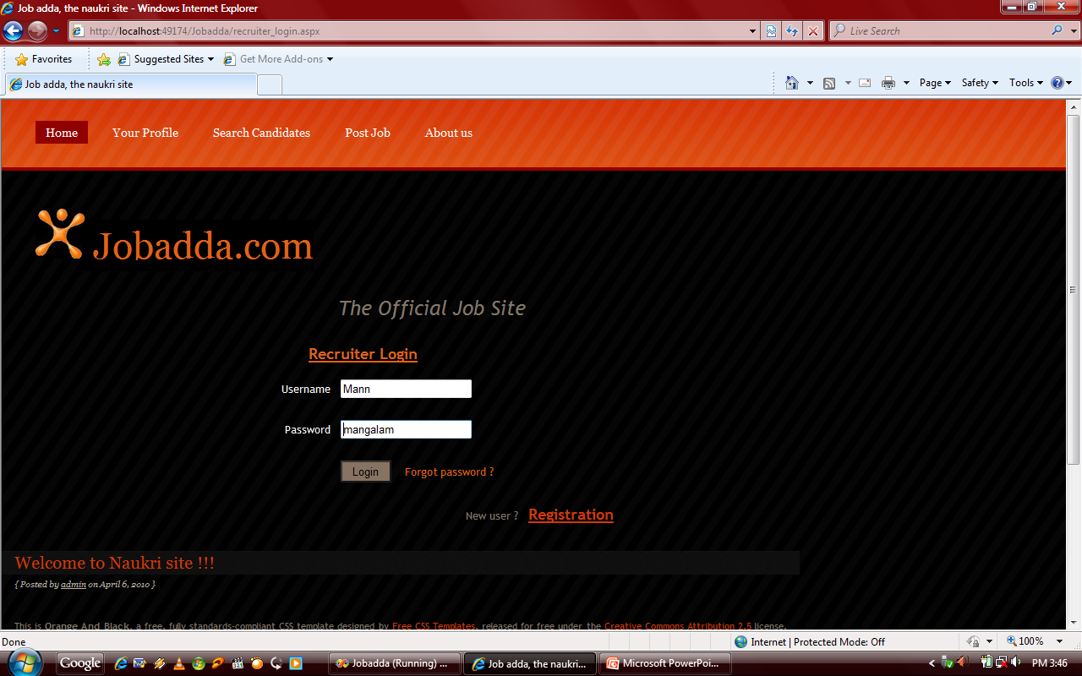

Recruiter Profile

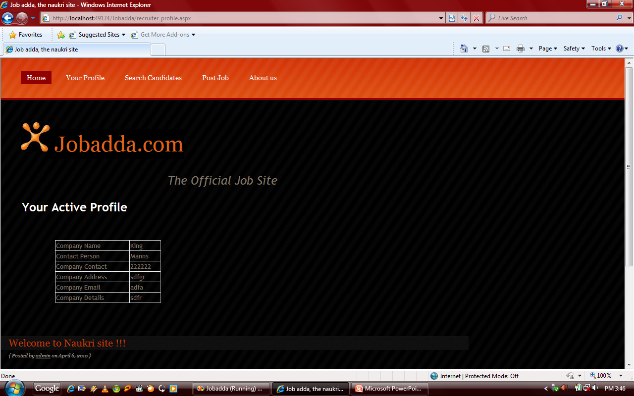

**ADMIN SECTION**

1. Manage registered users (Edit/Active/Inactive)
2. Manage Employers (Edit/Active/Inactive)
3. Manage Employers
4. Manage Job seekers
5. Manage Courses (Add/Edit)
6. Manage Specialization Courses (Add/Edit)
7. Manage Institutes (Add/Edit)
8. Manage Job Location (Add/Edit) International based.
9. Mange Functional Area
10. Manage Role Area
11. Manage Industries
12. Manage Plans
13. Admin Management (Add/Edit)
14. Automated Mails to job Seekers when any job post matching their profile.
15. All other automated mails, while registration, posting of job, applying of job, changing in plan, welcome mails, periodical job details to matched candidates, profile completion mail to jobseeker and Employers, etc.
16. Multi Level Section facility: Like: JOB APPLIED FOR, FUNCTIONAL AREA, INDUSTRIES, and PREFERRED LOCATION. (five Fields)
17. Summarized Details: Like how many clicks on today Job Posting, Resume Posting,
18. Space for Employer/Candidate’s Views, feedback or comments. Submission after only approval from Admin.
19. Communication between Employer & Candidate Thorough us only.
20. Automated Mails to update Resume.

**Admin section Screen shot**

Administrator Login

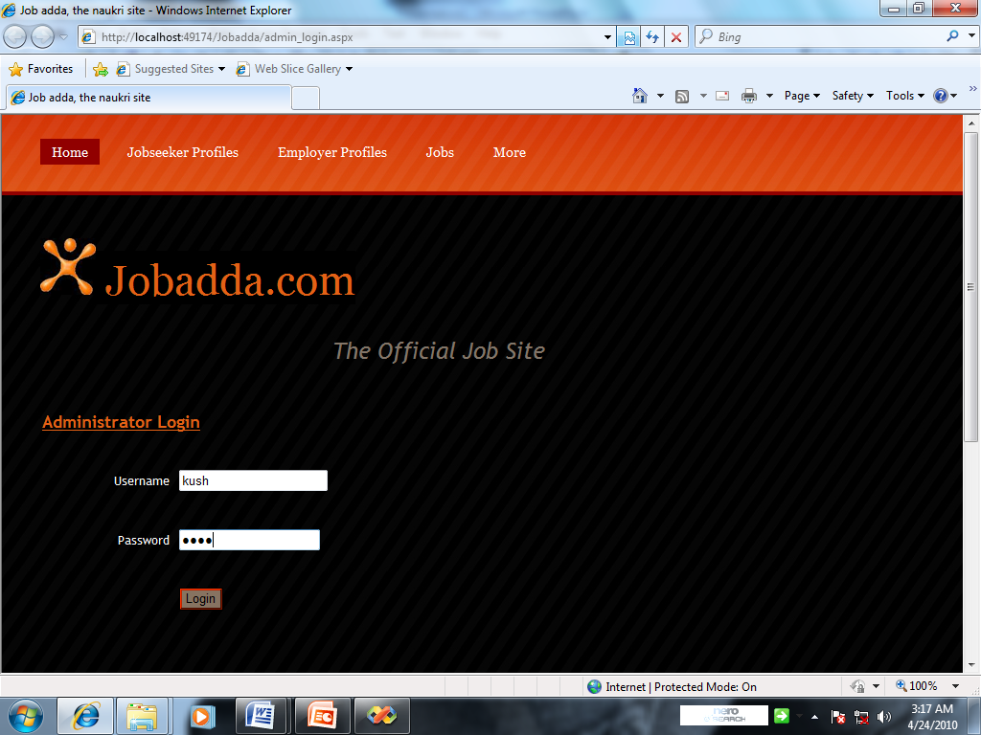

View Added Un & Pw

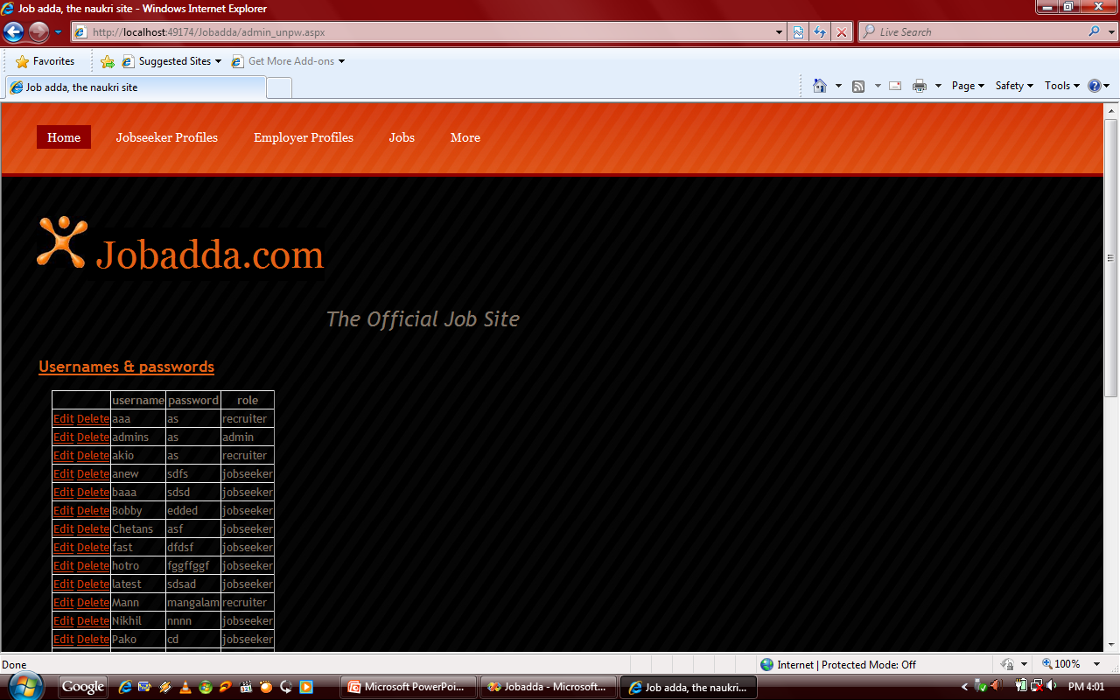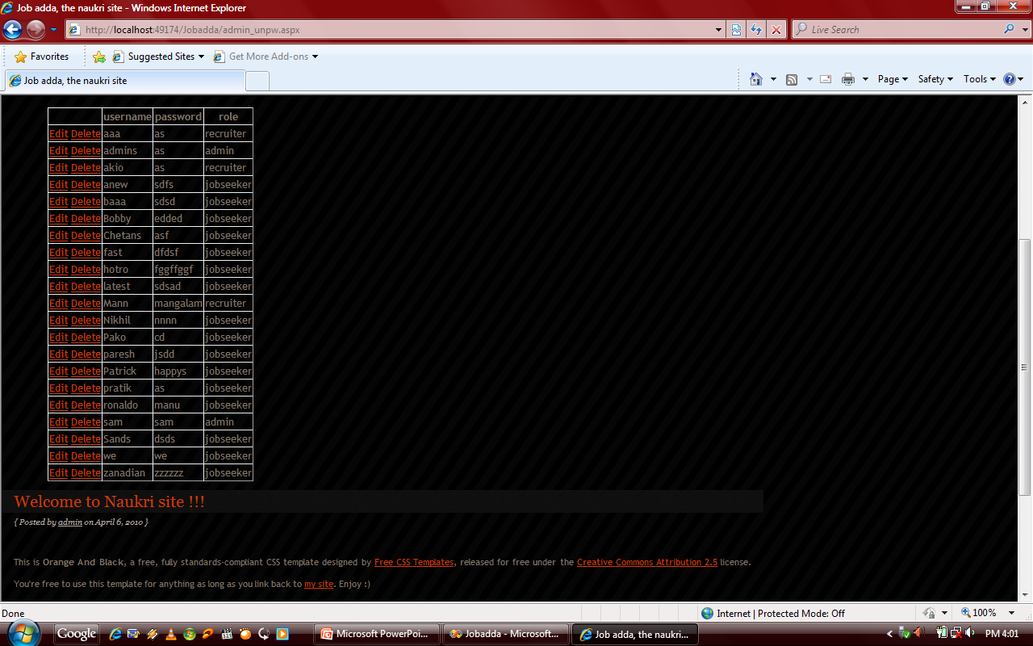

Employer’s Profile

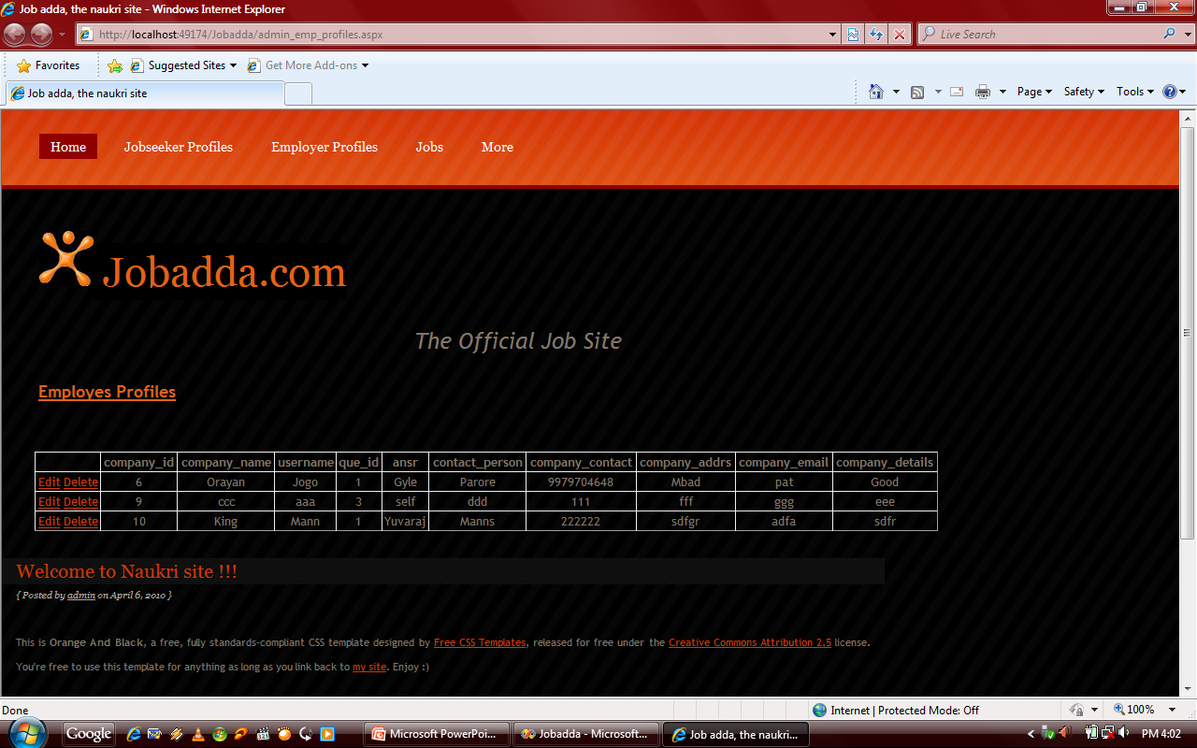

Post Jobs

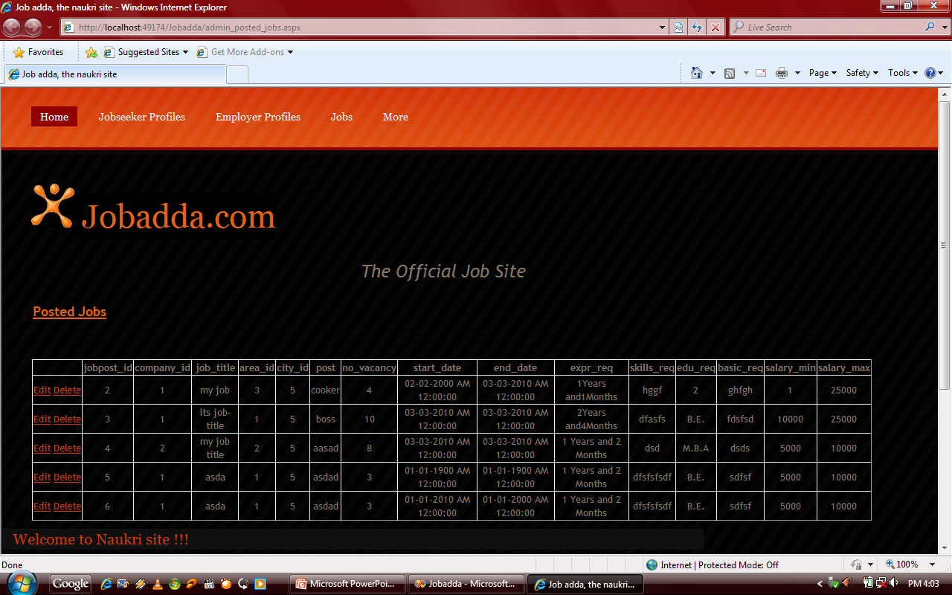

Admin More

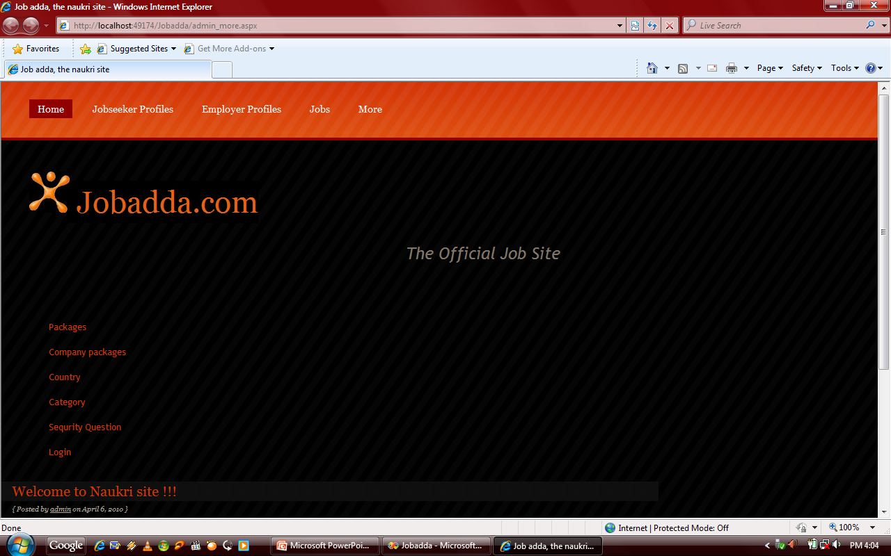

Add Package

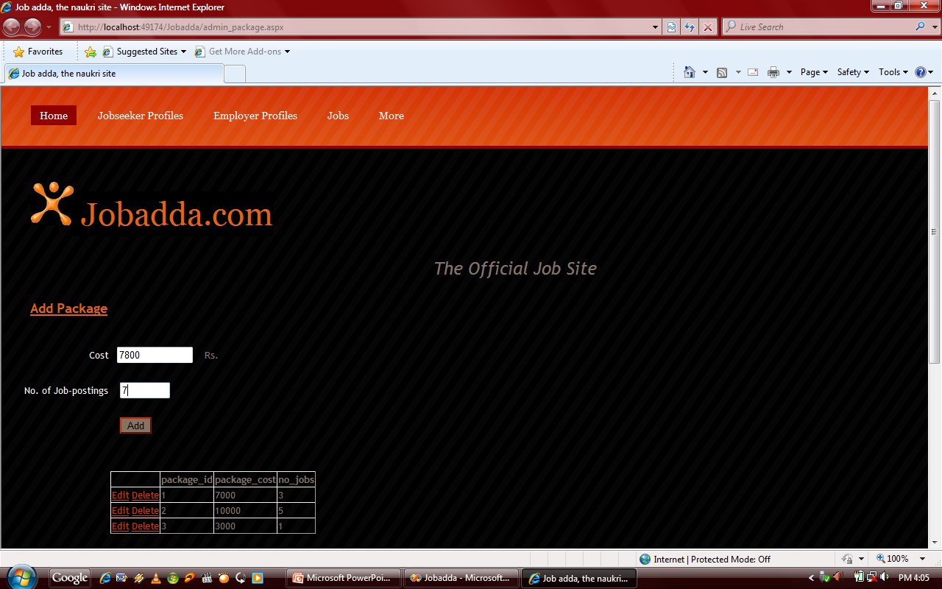

Posted Job

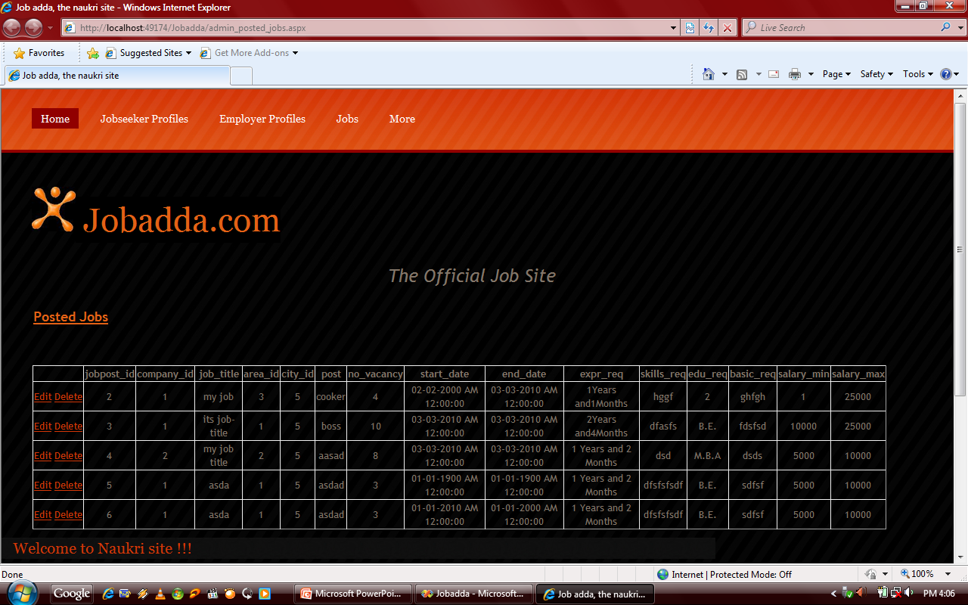

Security Question

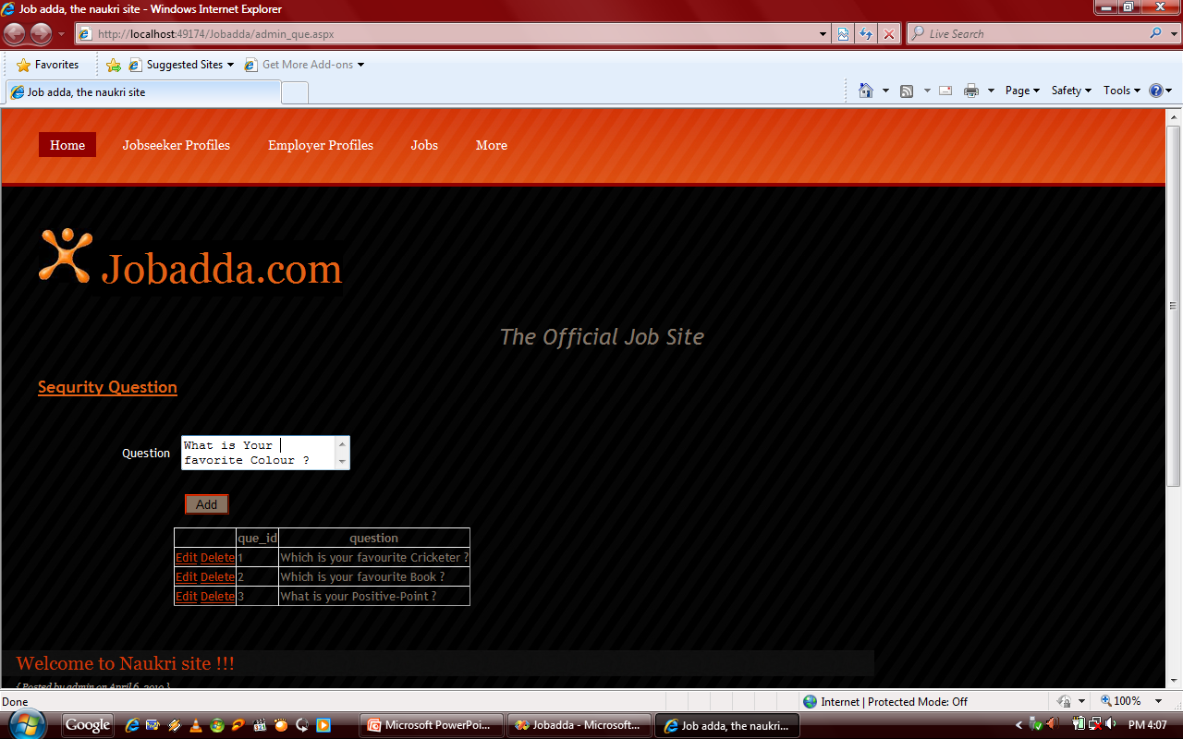

Company Package

